https://esp3d.io/esp3d-tft/v1.x/hardware/sunton-43-8048/index.html

4.3' ESP32-8048S043C
- ESP32-S3 based + SDReader + PSRAM + 4.3’ IPS TFT (800x480) with Capacitive touch screen
  - Aliexpress 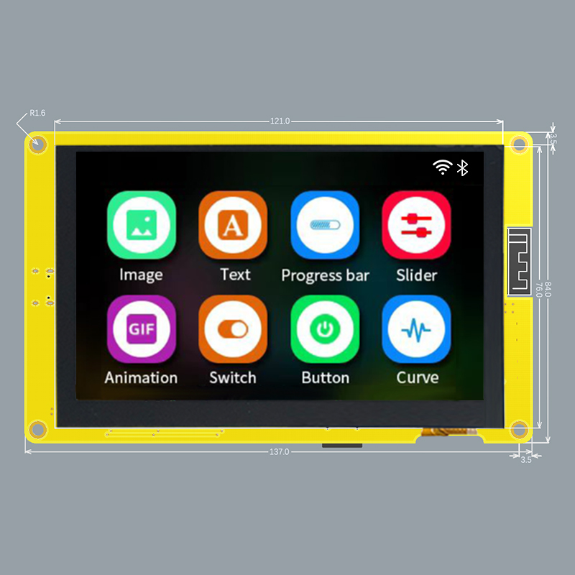 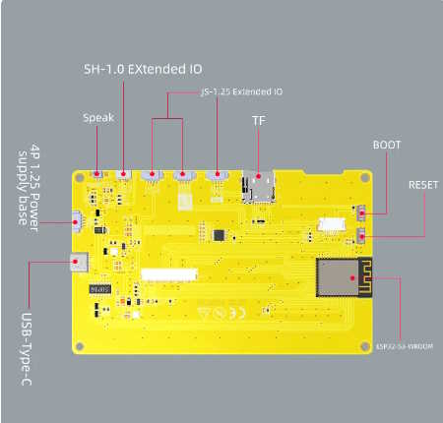

Features
- ESP32-S3 dual-core Xtensa 32-bit LX7 microprocessor, up to 240 MHz with 384KB ROM, 512KB SRAM. 2.4GHz WiFi and Bluetooth 5
- FLASH: 16MB
- PSRAM: 8MB
- Micro-SD card slot (SPI)
- 4.3-inch 800x480 IPS TFT display - ST7262 (Parallel RGB-565 interface)
  - (https://lang-ship.com/blog/work/esp32-4827s043/)
- Capacitive touch panel - GT911 (i2C - 0x5D or 0x14)
- 1 USB-C to Serial 0 (CH340C)
- I2C / SPI / GPIOs
- Boot and reset buttons
- Dimension: 181.0mm x 108.0mm
- Header P1 (4 pins) (UART): Gnd, Rx, Tx, +5V
- Header P2 (4 pins) (SPI): IO13, IO12, IO11, IO19
- Header P3 (4 pins) (USB/UART): IO20, IO19, IO18, IO17
- Header P4 (4 pins) : IO18, IO17, +3.3v, Gnd

Pins
Pin | Usage
GPIO 0 | BOOT_BTN
GPIO 1 | LCD_B4
GPIO 2 | TFT_BL
GPIO 3 | LCD_B1
GPIO 4 | LCD_G5
GPIO 5 | LCD_G0
GPIO 6 | LCD_G1
GPIO 7 | LCD_G2
GPIO 8 | LCD_B0
GPIO 9 | LCD_B3
GPIO 10 | SD_CS
GPIO 11 | SD_MOSI
GPIO 12 | SD_SCK
GPIO 13 | SD_MISO
GPIO 14 | LCD_R4
GPIO 15 | LCD_G3
GPIO 16 | LCD_G4
GPIO 17 | NC
GPIO 18 | CTP_INT*
GPIO 19 | CTP_SDA
GPIO 20 | CTP_SCL
GPIO 21 | LCD_R3
GPIO 33 | NA
GPIO 34 | NA
GPIO 35 | NC / NA
GPIO 36 | NC / NA
GPIO 37 | NC / NA
GPIO 38 | CTP_RST
GPIO 39 | LCD_HSYNC
GPIO 40 | LCD_DE
GPIO 41 | LCD_VSYNC
GPIO 42 | LCD_PCLK
GPIO 43 | U0TXD
GPIO 44 | U0RXD
GPIO 45 | LCD_R0
GPIO 46 | LCD_B2
GPIO 47 | LCD_R2
GPIO 48 | LCD_R1
* Requires Hardware Mod

Hardware Mod (Add Hardware Interrupt for GT911)
NOTE: This only applies to the screen with the Capacitive touch panel (ESP32_8048S043C)
By default, this board does not connect the Capacitive Touch Screen’s GT911 Interrupt pin to any GPIO pins. This means that the code has to use polling instead of hardware interrupts to determine when the screen is being touched. This results in excessive CPU utilization of greater than 80%. Making the below modifications results in a significantly reduced CPU utilization of under 10% on avg (on static screens).

Steps (see picture)
- Install a 0 ohm resistor or solder bridge across R17. This connects the GT911’s INT pin to GPIO18.
- (If installed) Remove (pull-up) resistor R5 (GPIO18 to 3V3). The GT911’s INT pin is not strong enough to drive GPIO18 low with this resistor installed.
- (If installed) Remove U1 (XPT2046). This is not needed for the Capacitive touch panel and may conflict with GPIO18 if left on the board.
NOTE: Remember to enable the HARDWARE_MOD_GT911_INT option in CMakeLists.txt

